Markerset: Rajapogal

Markers count:

Table of Contents

Lower body 2

Lower foot (12 markers per leg) 2

Upper foot (4 markers per side) 3

Pelvis (2 markers) 3

Upper body 4

Sacrum, Spine (T10, C7) & Acromion (7 markers) 4

Arms 5

Upper arms (10 markers per side) 5

Hands (3 markers per side) 6

Head 6

Skull (3 markers) 6

# Lower body

## Lower foot (12 markers per leg)

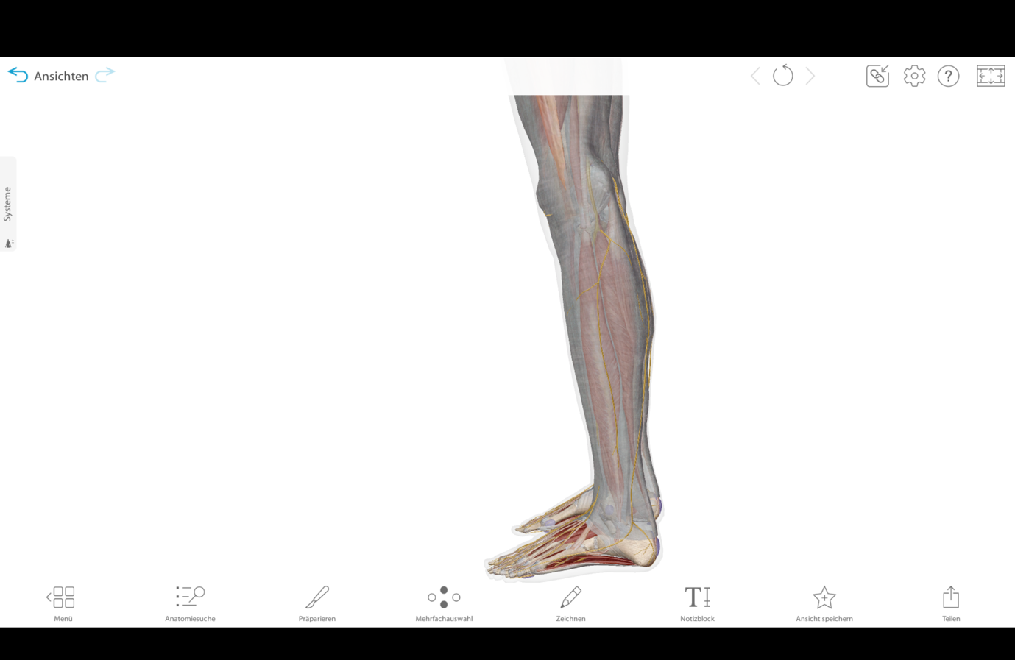

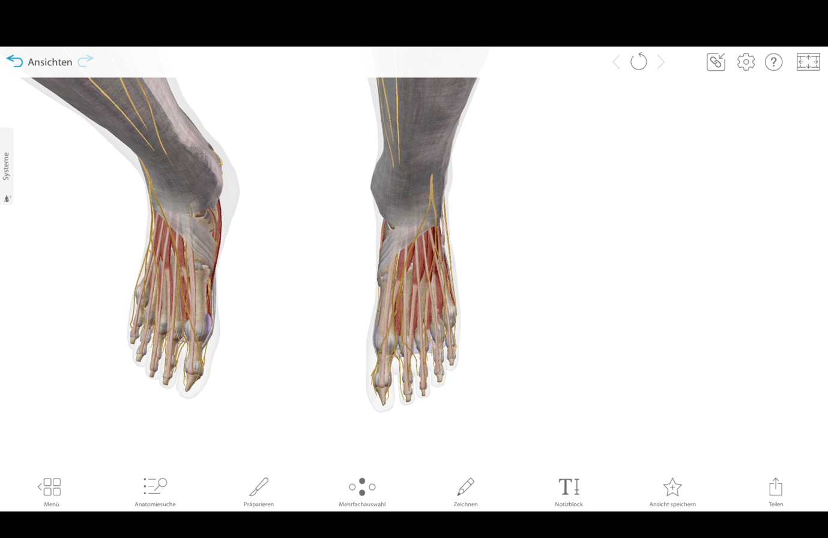

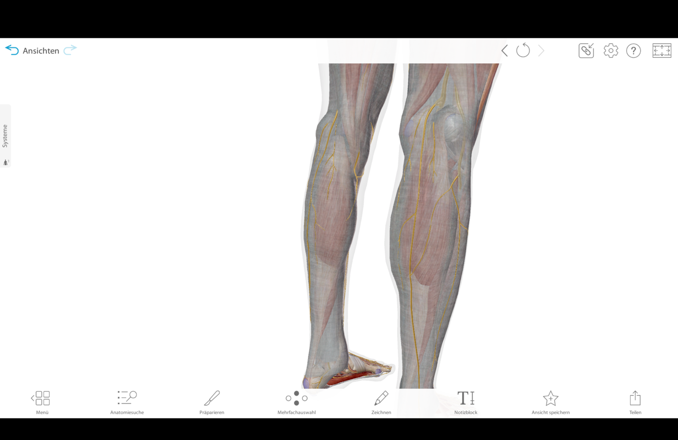

## Upper foot (4 markers per side)

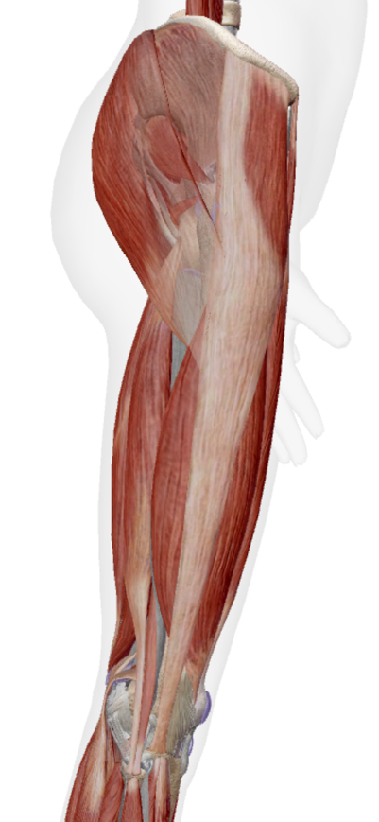

## Pelvis (2 markers)

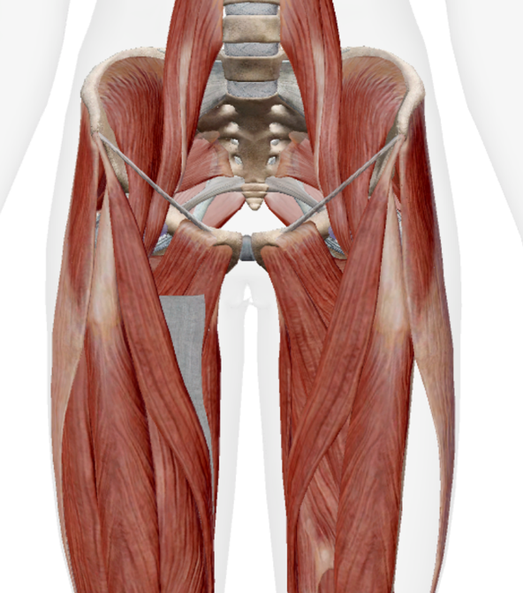

# Upper body

## Sacrum, Spine (T10, C7) & Acromion (7 markers)

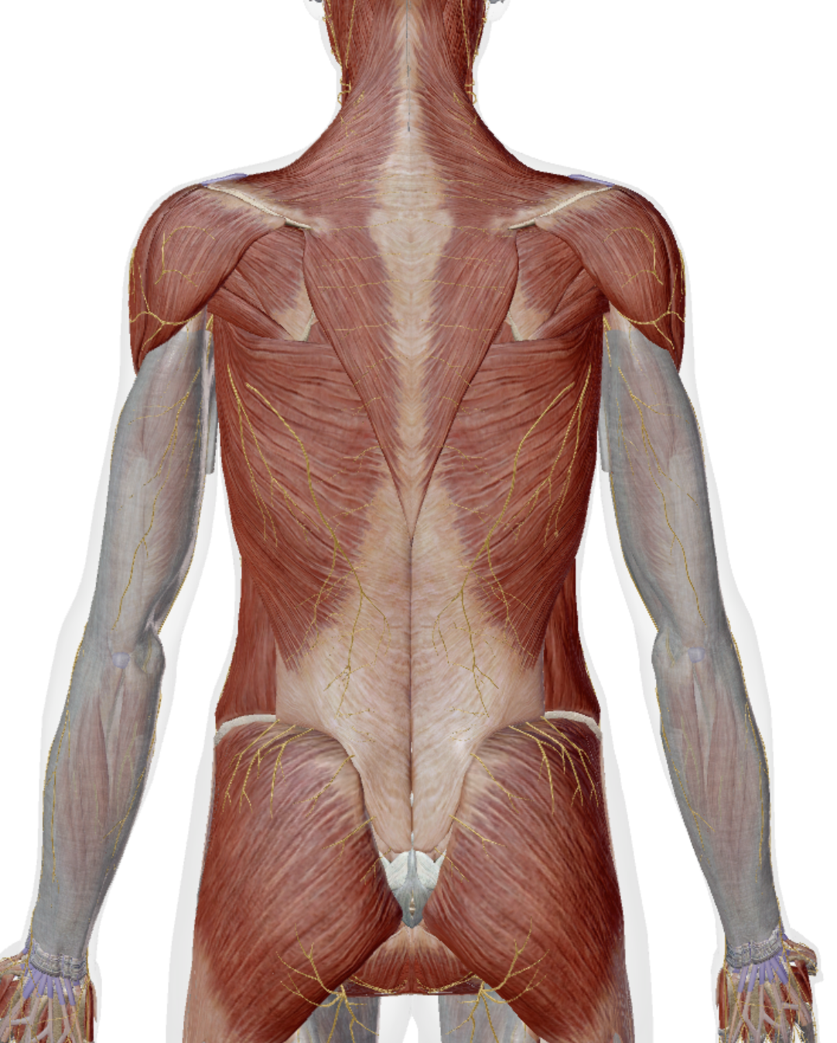

# Arms

## Upper arms (10 markers per side)

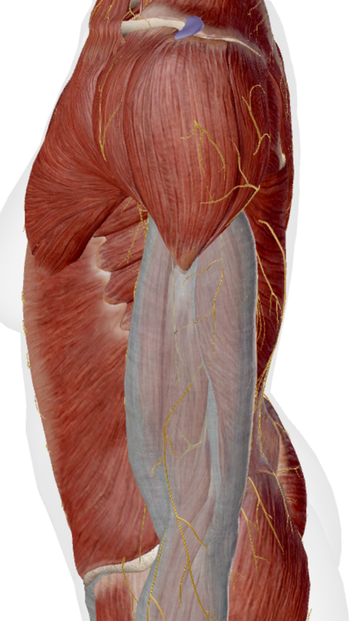

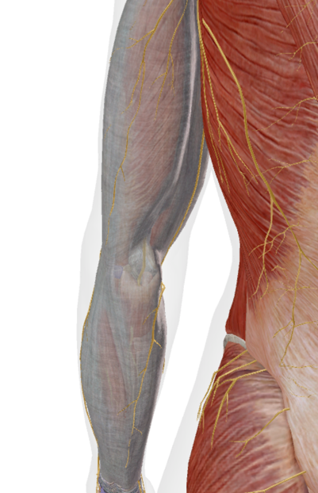

## Hands (3 markers per side)

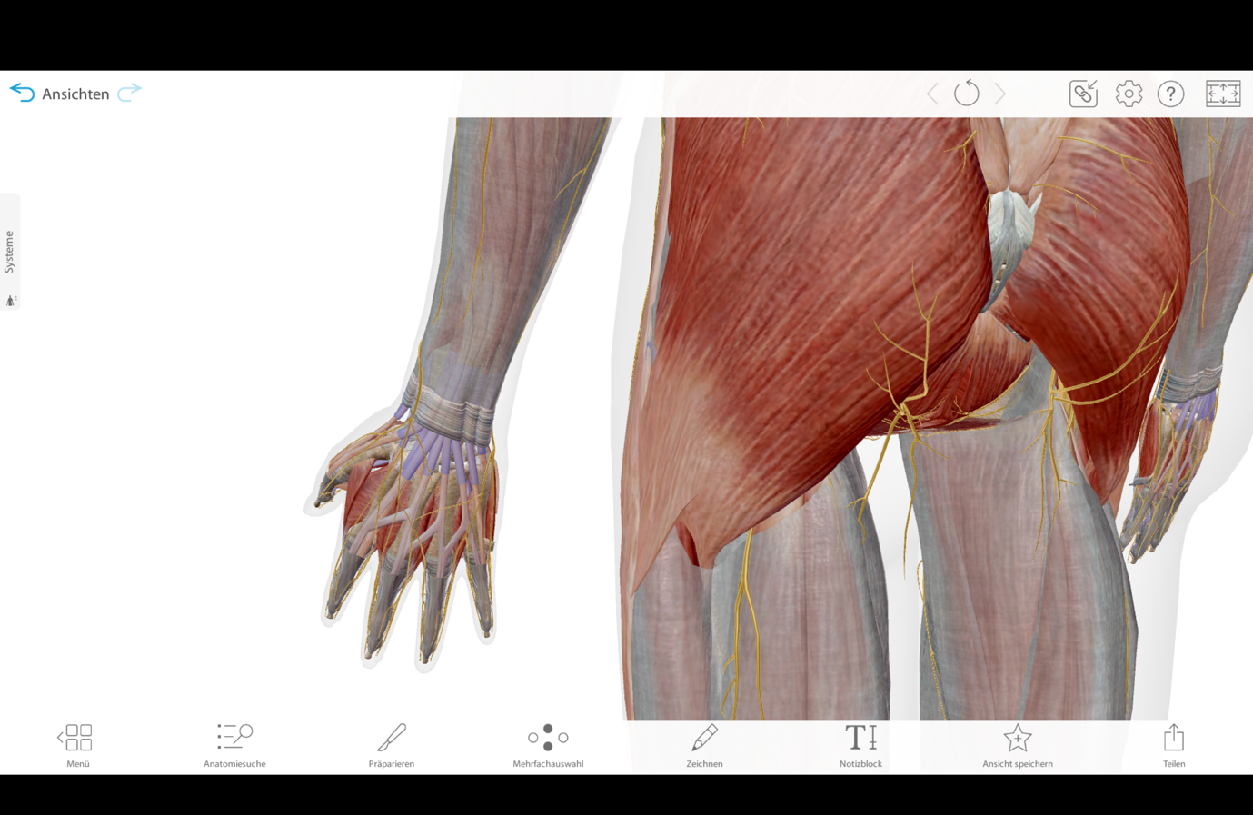

# Head

## Skull (3 markers)

